姓名：唐璐 | 专业：信息管理与信息系统 | 班级：20181171 | 学号：2018117135
科目： 安卓 |  | 实验日期：2021/6/22
实验题目：
【实验目的】

【实验环境及方式】
- 创建项目并定义一个服务
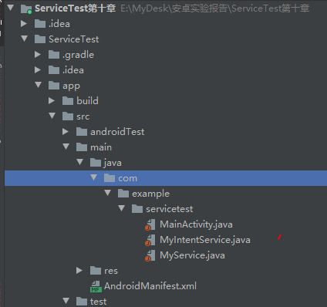
- 编写MyService的代码

public class MyService extends Service {
public MyService() {
}
private DownloadBinder mBinder = new DownloadBinder();
class DownloadBinder extends Binder {
public void startDownload() {
Log.d("MyService", "startDownload executed");
}
public int getProgress() {
Log.d("MyService", "getProgress executed");
return 0;
}
}
@Override
public IBinder onBind(Intent intent) {
return mBinder;
}
@Override
public void onCreate() {
super.onCreate();
Log.d("MyService", "onCreate executed");
Intent intent = new Intent(this, MainActivity.class);
PendingIntent pi = PendingIntent.getActivity(this, 0, intent, 0);
Notification notification = new NotificationCompat.Builder(this)
.setContentTitle("我的通知")
.setContentText("普通服务开启了")
.setWhen(System.currentTimeMillis())
.setSmallIcon(R.mipmap.ic_launcher)
.setLargeIcon(BitmapFactory.decodeResource(getResources(), R.mipmap.ic_launcher))
.setContentIntent(pi)
.build();
startForeground(1, notification);
}
@Override
public int onStartCommand(Intent intent, int flags, int startId) {
Log.d("MyService", "onStartCommand executed");
return super.onStartCommand(intent, flags, startId);
}
@Override
public void onDestroy() {
super.onDestroy();
Log.d("MyService", "onDestroy executed");
}
}

三、观察并修改AndroidMainfest文件的内容

<?xml version="1.0" encoding="utf-8"?>
<manifest xmlns:android="http://schemas.android.com/apk/res/android"
package="com.example.servicetest">
<application
android:allowBackup="true"
android:icon="@mipmap/ic_launcher"
android:label="@string/app_name"
android:supportsRtl="true"
android:theme="@style/AppTheme">
<activity android:name=".MainActivity">
<intent-filter>
<action android:name="android.intent.action.MAIN" />
<category android:name="android.intent.category.LAUNCHER" />
</intent-filter>
</activity>
<service
android:name=".MyService"
android:enabled="true"
android:exported="true" />
<service android:name=".MyIntentService" />
</application>
</manifest>

重写部分方法
@Override
protected void onCreate(Bundle savedInstanceState) {
super.onCreate(savedInstanceState);
setContentView(R.layout.activity_main);
Button startService = (Button) findViewById(R.id.start_service);
Button stopService = (Button) findViewById(R.id.stop_service);
startService.setOnClickListener(this);
stopService.setOnClickListener(this);
Button bindService = (Button) findViewById(R.id.bind_service);
Button unbindService = (Button) findViewById(R.id.unbind_service);
bindService.setOnClickListener(this);
unbindService.setOnClickListener(this);
Button startIntentService = (Button) findViewById(R.id.start_intent_service);
startIntentService.setOnClickListener(this);
}
@Override
public void onClick(View v) {
switch (v.getId()) {
case R.id.start_service:
Intent startIntent = new Intent(this, MyService.class);
startService(startIntent); // 启动服务
break;
case R.id.stop_service:
Intent stopIntent = new Intent(this, MyService.class);
stopService(stopIntent); // 停止服务
break;
case R.id.bind_service:
Intent bindIntent = new Intent(this, MyService.class);
bindService(bindIntent, connection, BIND_AUTO_CREATE); // 绑定服务
break;
case R.id.unbind_service:
unbindService(connection); // 解绑服务
break;
case R.id.start_intent_service:
// 打印主线程的id
Log.d("MainActivity", "Thread id is " + Thread.currentThread(). getId());
Intent intentService = new Intent(this, MyIntentService.class);
startService(intentService);
break;
default:
break;
}
}

- 运行代码
- 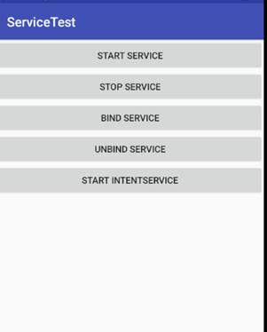
【教师评语和成绩】

成绩： 指导教师： 日期：

